## 测试记录

2019-09-18

1、关于登机口 变更的 播音。

根据现场 生产数据分析， 登机口变更 一般 发送在计划（SCHD）状态下， 不可能出现在 登机（BOR）后面

今天 生产数据 TV6046 先发送下面计划消息分别发送了 四次：

{"Airshowtype":"","Routeoid":73618,"Shareflightno":"","FlightDateTime":"2019-09-17T00:00:00","ExecutionDateTime":"2019-09-17T00:00:00","FlightNo2":"TV6046","FlightNo3":"TBA6046","AirlineCode2":"TV","AirlineCode3":"TBA","FlightNum":"6046","FlightMssion":"W/Z","FlightType":"D","DepFIV1NO3":"","DepFIV1NO4":"","DepFIV2NO3":"","DepFIV2NO4":"","ArrFIV1NO3":"","ArrFIV1NO4":"","ArrFIV2NO3":"","ArrFIV2NO4":"","Fiv1No3":"","Fiv1No4":"","Fiv2No3":"","Fiv2No4":"","ForgNo3":"LUM","ForgNo4":"ZPMS","FestNo3":"KMG","FestNo4":"ZPPP","DepPlanTime":"2019-09-17T12:15:00","DepForecastTime":"2019-09-17T12:15:00","DepartTime":"2019-09-17T12:32:00","ArrPlanTime":"2019-09-17T13:25:00","ArrForecastTime":"2019-09-17T13:16:00","ArriveTime":"2019-09-17T13:24:00","FlightStatus":"ARR","Gate":4,"Gateopentime":"2019-09-17T11:41:02","Gateclosetime":"2019-09-17T12:05:00","Carousel":-2147483648,"CheckinLoad":"","CheckinCounter":"","CheckinTimeStart":"2019-09-17T10:45:00","CheckinTimeEnd":"2019-09-17T11:45:00","FlightCirculationStatus":"NST","FlightAbnormalReason":"","Freg":"B6467","DepOrArrCode":"C","LocalAirportCode":"LUM","Xlsjtime":"1753-01-01T00:00:00","Xlxjtime":"1753-01-01T00:00:00","RouteType":"DELETEALL","Parkingcode":"104","Aircrafttype":"A319","Playtime":"","Playarea":"","Playtype":"","Dlytype":"","Dlytime":"","Counterno":"","Countertype":"","TableName":"V_FLIGHTDYNAMICDETAIL_AIRSHOW","TableSchema":"","Ismixed":false,"FooterSql":"","WhereSql":"","ClientIp":"","ClientMachineName":"","GroupSql":"","OrderSql":"","UserId":-2147483648,"UserName":"","IsPrintAll":false,"Operator":0}

{"Airshowtype":"","Routeoid":73702,"Shareflightno":"","FlightDateTime":"2019-09-18T00:00:00","ExecutionDateTime":"2019-09-18T00:00:00","FlightNo2":"TV6046","FlightNo3":"TBA6046","AirlineCode2":"TV","AirlineCode3":"TBA","FlightNum":"6046","FlightMssion":"W/Z","FlightType":"D","DepFIV1NO3":"","DepFIV1NO4":"","DepFIV2NO3":"","DepFIV2NO4":"","ArrFIV1NO3":"","ArrFIV1NO4":"","ArrFIV2NO3":"","ArrFIV2NO4":"","Fiv1No3":"","Fiv1No4":"","Fiv2No3":"","Fiv2No4":"","ForgNo3":"LUM","ForgNo4":"ZPMS","FestNo3":"KMG","FestNo4":"ZPPP","DepPlanTime":"2019-09-18T12:15:00","DepForecastTime":"2019-09-18T12:15:00","DepartTime":"1753-01-01T00:00:00","ArrPlanTime":"2019-09-18T13:25:00","ArrForecastTime":"2019-09-18T13:25:00","ArriveTime":"1753-01-01T00:00:00","FlightStatus":"NOR","Gate":-2147483648,"Gateopentime":"2019-09-18T11:45:00","Gateclosetime":"2019-09-18T12:05:00","Carousel":-2147483648,"CheckinLoad":"","CheckinCounter":"","CheckinTimeStart":"1753-01-01T00:00:00","CheckinTimeEnd":"1753-01-01T00:00:00","FlightCirculationStatus":"SCHD","FlightAbnormalReason":"","Freg":"B6426","DepOrArrCode":"C","LocalAirportCode":"LUM","Xlsjtime":"1753-01-01T00:00:00","Xlxjtime":"1753-01-01T00:00:00","RouteType":"ADDALL","Parkingcode":"","Aircrafttype":"A319","Playtime":"","Playarea":"","Playtype":"","Dlytype":"","Dlytime":"","Counterno":"","Countertype":"","TableName":"V_FLIGHTDYNAMICDETAIL_AIRSHOW","TableSchema":"","Ismixed":false,"FooterSql":"","WhereSql":"","ClientIp":"","ClientMachineName":"","GroupSql":"","OrderSql":"","UserId":-2147483648,"UserName":"","IsPrintAll":false,"Operator":0}

{"Airshowtype":"","Routeoid":73702,"Shareflightno":"","FlightDateTime":"2019-09-18T00:00:00","ExecutionDateTime":"2019-09-18T00:00:00","FlightNo2":"TV6046","FlightNo3":"TBA6046","AirlineCode2":"TV","AirlineCode3":"TBA","FlightNum":"6046","FlightMssion":"W/Z","FlightType":"D","DepFIV1NO3":"","DepFIV1NO4":"","DepFIV2NO3":"","DepFIV2NO4":"","ArrFIV1NO3":"","ArrFIV1NO4":"","ArrFIV2NO3":"","ArrFIV2NO4":"","Fiv1No3":"","Fiv1No4":"","Fiv2No3":"","Fiv2No4":"","ForgNo3":"LUM","ForgNo4":"ZPMS","FestNo3":"KMG","FestNo4":"ZPPP","DepPlanTime":"2019-09-18T12:15:00","DepForecastTime":"2019-09-18T12:15:00","DepartTime":"1753-01-01T00:00:00","ArrPlanTime":"2019-09-18T13:25:00","ArrForecastTime":"2019-09-18T13:25:00","ArriveTime":"1753-01-01T00:00:00","FlightStatus":"NOR","Gate":-2147483648,"Gateopentime":"2019-09-18T11:45:00","Gateclosetime":"2019-09-18T12:05:00","Carousel":-2147483648,"CheckinLoad":"","CheckinCounter":"","CheckinTimeStart":"1753-01-01T00:00:00","CheckinTimeEnd":"1753-01-01T00:00:00","FlightCirculationStatus":"SCHD","FlightAbnormalReason":"","Freg":"B6426","DepOrArrCode":"C","LocalAirportCode":"LUM","Xlsjtime":"1753-01-01T00:00:00","Xlxjtime":"1753-01-01T00:00:00","RouteType":"DELETEALL","Parkingcode":"","Aircrafttype":"A319","Playtime":"","Playarea":"","Playtype":"","Dlytype":"","Dlytime":"","Counterno":"","Countertype":"","TableName":"V_FLIGHTDYNAMICDETAIL_AIRSHOW","TableSchema":"","Ismixed":false,"FooterSql":"","WhereSql":"","ClientIp":"","ClientMachineName":"","GroupSql":"","OrderSql":"","UserId":-2147483648,"UserName":"","IsPrintAll":false,"Operator":0}

{"Airshowtype":"","Routeoid":73702,"Shareflightno":"","FlightDateTime":"2019-09-18T00:00:00","ExecutionDateTime":"2019-09-18T00:00:00","FlightNo2":"TV6046","FlightNo3":"TBA6046","AirlineCode2":"TV","AirlineCode3":"TBA","FlightNum":"6046","FlightMssion":"W/Z","FlightType":"D","DepFIV1NO3":"","DepFIV1NO4":"","DepFIV2NO3":"","DepFIV2NO4":"","ArrFIV1NO3":"","ArrFIV1NO4":"","ArrFIV2NO3":"","ArrFIV2NO4":"","Fiv1No3":"","Fiv1No4":"","Fiv2No3":"","Fiv2No4":"","ForgNo3":"LUM","ForgNo4":"ZPMS","FestNo3":"KMG","FestNo4":"ZPPP","DepPlanTime":"2019-09-18T12:15:00","DepForecastTime":"2019-09-18T12:15:00","DepartTime":"1753-01-01T00:00:00","ArrPlanTime":"2019-09-18T13:25:00","ArrForecastTime":"2019-09-18T13:25:00","ArriveTime":"1753-01-01T00:00:00","FlightStatus":"NOR","Gate":6,"Gateopentime":"2019-09-18T11:45:00","Gateclosetime":"2019-09-18T12:05:00","Carousel":-2147483648,"CheckinLoad":"","CheckinCounter":"","CheckinTimeStart":"2019-09-18T10:45:00","CheckinTimeEnd":"2019-09-18T11:45:00","FlightCirculationStatus":"SCHD","FlightAbnormalReason":"","Freg":"B6426","DepOrArrCode":"C","LocalAirportCode":"LUM","Xlsjtime":"1753-01-01T00:00:00","Xlxjtime":"1753-01-01T00:00:00","RouteType":"ADD","Parkingcode":"102","Aircrafttype":"A319","Playtime":"","Playarea":"","Playtype":"","Dlytype":"","Dlytime":"","Counterno":"","Countertype":"","TableName":"V_FLIGHTDYNAMICDETAIL_AIRSHOW","TableSchema":"","Ismixed":false,"FooterSql":"","WhereSql":"","ClientIp":"","ClientMachineName":"","GroupSql":"","OrderSql":"","UserId":-2147483648,"UserName":"","IsPrintAll":false,"Operator":0}

广播系统有变更 播音（登机口变更），但是都是 早上 5点多钟，很多变更，应该与 航班计划起飞时间 比较一致，三小时（时间可配） 范围内的 播，超过不播。

1. 关于芒市 开往 芒市 的 消息。

{"Airshowtype":"","Routeoid":73645,"Shareflightno":"","FlightDateTime":"2019-09-17T00:00:00","ExecutionDateTime":"2019-09-17T00:00:00","FlightNo2":"CFI047","FlightNo3":"CFII047","AirlineCode2":"CF","AirlineCode3":"CFI","FlightNum":"I047","FlightMssion":"F/J","FlightType":"D","DepFIV1NO3":"","DepFIV1NO4":"","DepFIV2NO3":"","DepFIV2NO4":"","ArrFIV1NO3":"","ArrFIV1NO4":"","ArrFIV2NO3":"","ArrFIV2NO4":"","Fiv1No3":"","Fiv1No4":"","Fiv2No3":"","Fiv2No4":"","ForgNo3":"LUM","ForgNo4":"ZPMS","FestNo3":"LUM","FestNo4":"ZPMS","DepPlanTime":"2019-09-17T09:00:00","DepForecastTime":"2019-09-17T09:00:00","DepartTime":"2019-09-17T09:47:00","ArrPlanTime":"2019-09-17T20:00:00","ArrForecastTime":"2019-09-17T20:47:00","ArriveTime":"2019-09-17T12:24:00","FlightStatus":"FAL","Gate":1,"Gateopentime":"2019-09-17T08:30:00","Gateclosetime":"2019-09-17T08:50:00","Carousel":1,"CheckinLoad":"","CheckinCounter":"","CheckinTimeStart":"2019-09-17T07:30:00","CheckinTimeEnd":"2019-09-17T08:30:00","FlightCirculationStatus":"ARR","FlightAbnormalReason":"","Freg":"B9329","DepOrArrCode":"J","LocalAirportCode":"LUM","Xlsjtime":"1753-01-01T00:00:00","Xlxjtime":"1753-01-01T00:00:00","RouteType":"MODIFY","Parkingcode":"112","Aircrafttype":"C680","Playtime":"","Playarea":"","Playtype":"","Dlytype":"","Dlytime":"","Counterno":"","Countertype":"","TableName":"V_FLIGHTDYNAMICDETAIL_AIRSHOW","TableSchema":"","Ismixed":false,"FooterSql":"","WhereSql":"","ClientIp":"","ClientMachineName":"","GroupSql":"","OrderSql":"","UserId":-2147483648,"UserName":"","IsPrintAll":false,"Operator":0}

测试一下。

1. 更新后的测试记录

**明天您们把这个测试一下。自动，人工，人工插播，切换测试一下。**

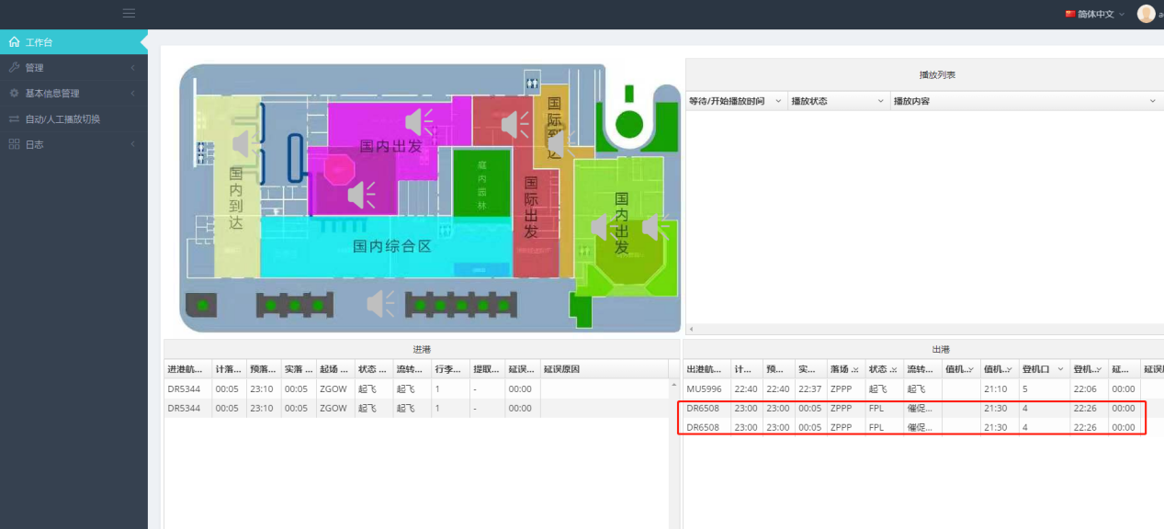

同一航班显示多条记录，生成多条语音片。

